Project Design Phase
Solution Architecture
Date | 15 February 2025
Team ID | SWTID-2026-6425
Project Name | EduGenie – AI-Powered Learning Assistant
Maximum Marks | 4 Marks

Solution Architecture:
EduGenie bridges the identified student-learning problems with an AI-powered web solution. The architecture defines the structure and interaction of the user interface, FastAPI application, learning feature modules and Google Gemini service.
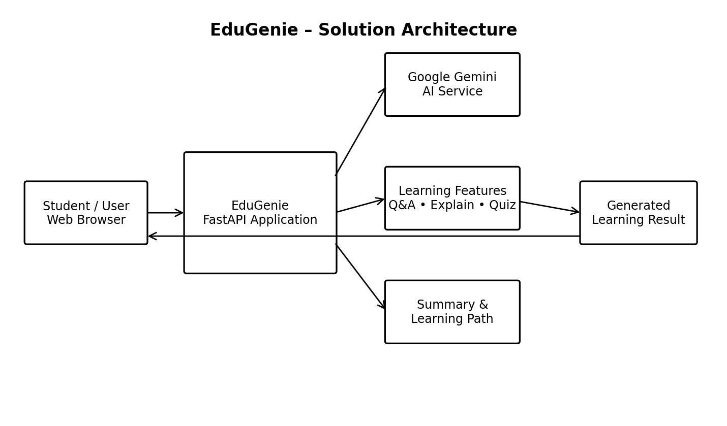
Figure 1: EduGenie solution architecture and learning-request flow.
Architecture Flow: Student → Web Interface → FastAPI Application → Learning Feature / Gemini Service → Generated Learning Result → Web Interface.

